CHAPTER 1
INTRODUCTION

Robotics can be described as the current pinnacle of technical development Today, robots mine minerals, assemble semi-processed materials into automobile components and assemble those components into automobile. Robot arms, or manipulators, comprise a 2 billion dollar industry. Bolted at its shoulder to a specific position in the assembly line, the robot arm can move with great speed and accuracy to perform repetitive tasks such as spot welding and painting. In the electronics industry, manipulators place surface-mounted components with superhuman precision, making the portable telephone and laptop computer possible. Yet, for all of their successes, these commercial robots suffer from a fundamental disadvantage: lack of mobility. A fixed manipulator has a limited range of motion that depends on where it is bolted down. In contrast, a mobile robot would be able to travel throughout the manufacturing plant, flexibly applying its talents wherever it is most effective. The mobile robot is an automatic machine capable of locomotion. The main classifications include Unmanned Aerial Vehicle (UAV), Unmanned Ground Vehicle (UGV), Manned Aerial Vehicle (MAV), Autonomous Ground Vehicle (AGV), humanoids etc. Mobile robots are unmanned ground vehicles with wide application such as military application, security settings, household applications such as gardening, vacuum cleaning etc. Mobile robots are capable of sensing its surrounding environment, interpreting the sensed information to obtain the knowledge of its location and the environment, and planning a real-time trajectory to reach the object. Obstacle avoidance is one of the main challenges in this field. The main aim of mobile robots will be target reaching by avoiding the obstacles in its path. Nowadays, mobile robots are a promising technology that will improve the quality of life by providing collision avoidance, reducing traffic gridlock, and allowing the replacement of dangerous tasks currently performed by human drivers. The path-planning for the objective of obstacle avoidance, which is one of the key issues in the mobile robot navigation, is the major topic to be investigated in this study.
A differential drive robot can be used for the application of land mine detection which is the main focus of this paper. A switching path planning control scheme is proposed which switches between the path tracking and obstacle avoidance control, helps the robot in efficiently reaching the target avoiding the obstacles in the unknown environments with less memory size. For tracking, the Carrot Chasing Algorithm is used. In obstacle avoidance, an algorithm is designed using the sensors and obstacle position. Intelligent adaptive schemes are used to avoid the uncertainties from external environment and sensor noises which give way to more adaptive and easier approach. Thus, for obstacle avoidance, fuzzy logic controller using Tagaki- Sugeno model is designed. The variation in sensor inputs is indicated in terms of distance. This distance is taken as one of the inputs while designing the fuzzy. Thus, the sensor variation indicated as distance variation is minimised using fuzzy design.
In chapter 2, literature survey of tracking with obstacle avoidance of mobile robots with different approaches is explained. In chapter 3, tracking algorithm for mobile robot is explained. In chapter 4, obstacle avoidance algorithms are explained. In chapter 5, combination of tracking with obstacle avoidance is explained along with the comparison between the algorithm and fuzzy based algorithm.

CHAPTER 2
LITERATURE SURVEY

2.1 INTRODUCTION

In this chapter, literature survey on various papers of tracking with obstacle avoidance of mobile robots is presented. In literature, different methods for tracking with obstacle avoidance are found. All these methods have their own advantages and disadvantages. A study of some of the methods and papers are given in this chapter..
Yoshio Yamamoto and Xiaoping Yun [1] proposed a control algorithm for the platform so that the manipulator is always positioned at the preferred configurations measured by its manipulability. It is desirable that the mobile platform is able to move as to position the manipulator in a certain preferred configurations. In this paper, a dynamic model of the mobile robot is developed. The main two methods of modelling are Newton method and Lagrange method. Here, Lagrange method is used. The basic lagrangian is defined as the difference between kinetic energy and potential energy. Here, the potential energy is considered as zero since the mobile robot is a ground vehicle. The energy is given as total kinetic energy [7],
T=$T_{l}+T_{r}+T_{kr}$ (2.1)
where,
$T_{l}=$(1/2)M${v_{c}}^{2}$= (1/2)M($\dot{{x_{c}}^{2}}$+$\dot{{y_{c}}^{2} }$) (2.2)
$T_{r}=(1/2{)I}_{A}\dot{ϕ^{2}}$ (2.3)
$T_{kr}$= (1/2)$I_{0}\dot{{θ_{R}}^{2}}$+ (1/2)$I_{0}\dot{{θ_{L}}^{2}}$ (2.4)
$T_{l}$- kinetic energy due to pure translation of vehicle
$T_{r}-$kinetic energy of rotation of vehicle
$T_{kr}$-kinetic energy of rotation of motors and wheels
On applying lagrangian equations,
$\frac{d}{dt}$($\frac{∂L}{∂\dot{x_{c}}}$) - ($\frac{∂L}{∂x_{c}}$) =0 (2.5)
$\frac{d}{dt}$($\frac{∂L}{∂\dot{y_{c}}}$) - ($\frac{∂L}{∂y_{c}}$) =0 (2.6)
$\frac{d}{dt}$($\frac{∂L}{∂\dot{ϕ}}$) - ($\frac{∂L}{∂ϕ}$) =0 (2.7)
$\frac{d}{dt}$($\frac{∂L}{∂\dot{θ_{R}}}$) - ($\frac{∂L}{∂θ_{R}}$) =$τ_{R}$ (2.8)
$\frac{d}{dt}$($\frac{∂L}{∂\dot{θ_{L}}}$) - ($\frac{∂L}{∂θ_{L}}$) =$τ_{L}$ (2.9)
where $τ_{R}$ and $τ_{L}$ are right and left actuation torques
The state variables [1] considered for the mobile robot are,
q=${(x}_{c}{,y}_{c,}{ϕ,θ}_{r},θ_{l})$ (2.10)
in which $x_{c},y_{c} are$position coordinates,Φ is the orientation of mobile robot $θ_{r},θ_{l}$are angular position for the left and right driving wheels.

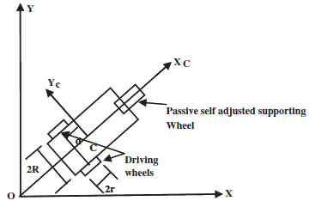
Figure 2.1 Orientation of mobile robot

Figure 1.1 shows the orientation of mobile robot [1]. The two main non holonomic constraints [1] considered for the robot are:
- Platform motion in the direction of axis of symmetry ie,
$\dot{{ y}_{c}}coscos ϕ -\dot{x_{c}}sinsin ϕ -d\dot{ϕ}=0$ (2.11)
2) Rolling constraints for left and right wheels are given by the equations,
$\dot{{ x}_{c}}coscos ϕ +\dot{y_{c}}sinsin ϕ +b\dot{ϕ}=r\dot{θ_{r}}$ (2.12)
$\dot{{ x}_{c}}coscos ϕ +\dot{y_{c}}sinsin ϕ -b\dot{ϕ}=r\dot{θ_{l}}$ (2.13)
then the above three constraints can written as
A(q)$\dot{q}$=0 (2.14)
where, A(q) = $\left[ϕ -coscos ϕ -coscos ϕ coscos ϕ -sinsin ϕ -sinsin ϕ -d 0 0 -b r 0 b 0 r \right]$

On writing the five equations of motion in state space representation

M(q)$\ddot{q}$+V(q,$\dot{q}$)=E(q)τ-$A^{T}$λ (2.15)

where, M(q) is the N x N inertia matrix, V(q,$\dot{q}$) is the N x 1 vector of position and velocity dependent forces, E(q) is the N x r input transformation matrix, and τ is the r dimensional input vector.
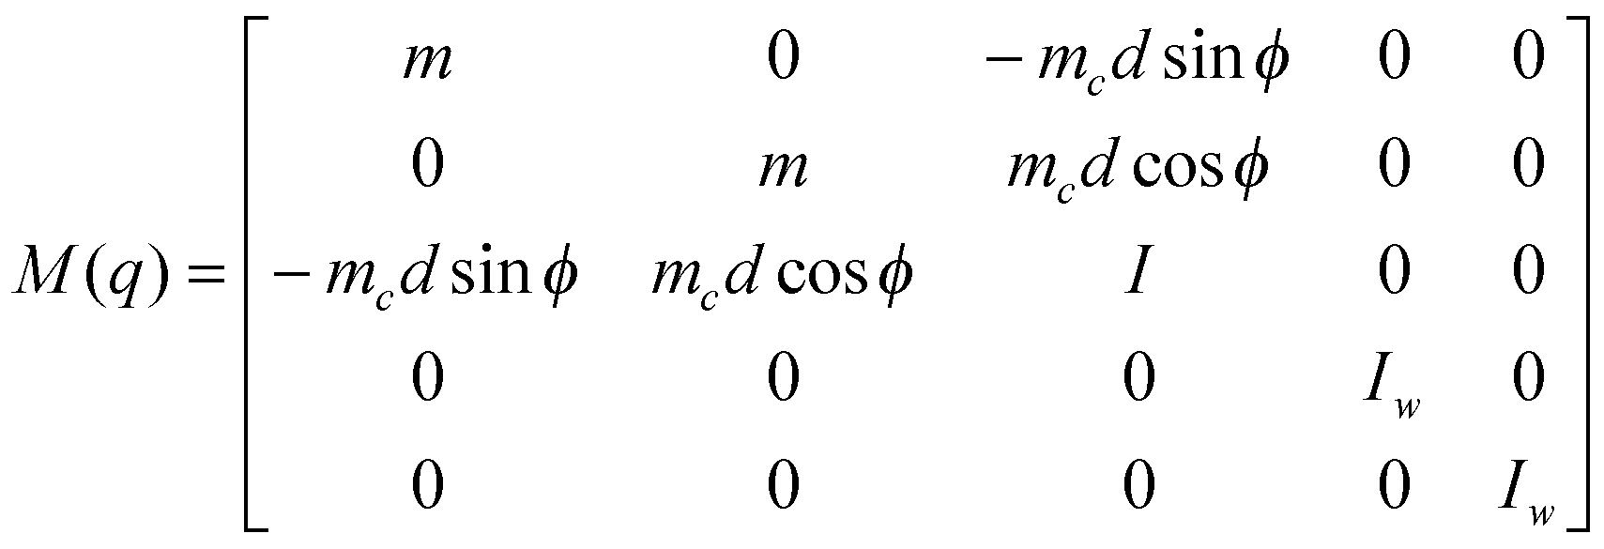

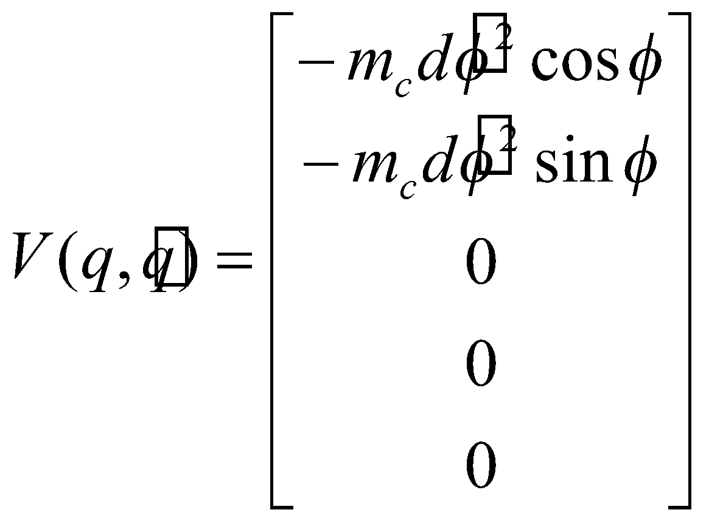
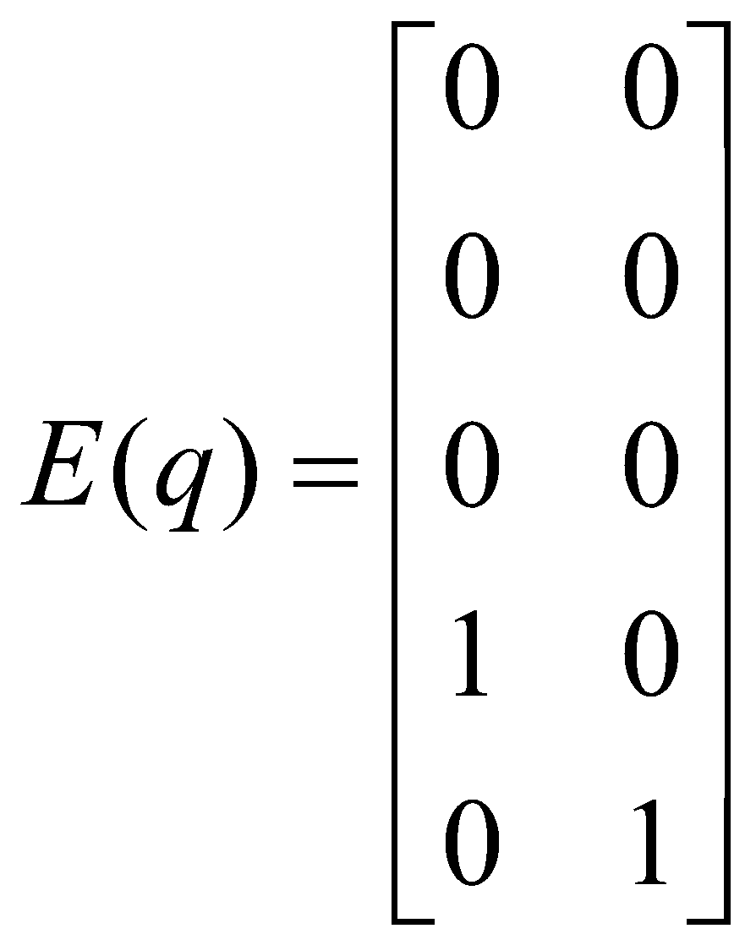

This dynamic model of mobile robot is used in the control algorithm proposed in this report.
M. Wang, J.N.K. Liu [2] explained a method which uses a minimum risk approach. Memory grid map is used for modelling the robot environment. Regional direction with minimum risk is considered i.e., minimum number of obstacle and trajectory memory dots decides the shortest path. Fuzzy logic framework is done using Mamdani inference system is used and the defuzzification method is the centroid or centre of gravity. The advantage of this method is that it helped to escape from local minimum and the main disadvantage this method faced is high power consumption and time consuming to reach the target.
W.L. Xu, S.K. Tso, [3] used the fundamental principle of reactive robot navigation i.e. target attracts the robot, while the obstacle repels it. Fuzzy reactive control incorporating a Local target switching scheme is explained in this paper. Sensed ranging signals and relative target positions are used as the fuzzy inputs where as robot reactive behaviour are used for framing the fuzzy rules .Steering angle and velocity change of the robots were taken as fuzzy outputs. The main advantage of this method is fast decision making and response time. The main disadvantage of this mobile robot is that it failed to reach the goal in concave and recursive U -shaped environment, so it is not applicable in multiple dead end situations.
G.Antonelli, S.Chiaverini, G.Fusco [4], designed a fuzzy performs for target seeking and obstacle avoidance. Actual – virtual target switching scheme is used. Also, the sum of all turning angles should be near to $0^{0}$. Advantage of this method is that it solves the problem of limit cycles at the multiple dead end traps. Disadvantage is that the method fails at the point where the sum of angles does not become zero like in G shape.
Rong-Jong Wain, Chia-MingLiu, You-WeiLin [5], designed a switching path planning control scheme without detailed environmental information. Different modes are designed to reach the goal. It includes motion tracking mode, obstacle avoidance mode, self-rotation mode, robot state selection mode. Each mode is designed separately and switched. The main advantages of this design is that it provides better target tracking efficiency than other methods, less time consumption, works efficiently in all unknown environments like U shape, G shape, multiple dead ends etc, less computational burden. The disadvantages it has are moving obstacles cannot be avoided, and the sensor noise leads to uncertainty.

2.2 CONCLUSION
Literature survey on various papers in the area of tracking with obstacle avoidance of mobile robots was done. From all the papers it was found that fuzzy design suited the best for fast response time. For efficient tracking, switching algorithm could give a good result. The uncertainties due to the sensor noises, affecting the system can be avoided using a fuzzy logic controller. A switching scheme between the algorithms is done to reduce complexity.

CHAPTER 3
TRACKING
Path planning is the process of obtaining an optimum path for the mobile robot from the current location to the desired target location. Path following algorithms [6] ensure that the mobile robot will follow a predefined paths in three or two dimensions. A simplest approach to follow a desired path is to introduce a virtual target point (VTP) on the path and direct the mobile robot to chase VTP. As time progresses, the mobile robot approaches towards the path and eventually follow the path. In this approach, the VTP is called the Carrot and the robot chases the carrot, hence the name Carrot chasing algorithm. In the missile guidance and aerospace literature, this algorithm is also called the “rabbit-chasing” algorithm.

3.1 INTRODUCTION

One approach to follow a desired path is to introduce a Virtual Target Point (VTP) [6] on the path and make the mobile robot chase the VTP. The robot updates its heading direction toward the VTP. As time progresses, the robot will move toward the path and asymptotically follow the path. Carrot chasing algorithm [6] is simple to implement but it has a limitation that it is not robust to large disturbances. In this chapter, the algorithm for defining the path, both straight line and loiter, tracking control and the simulation results for these are explained in detail.

  - WHEELED MOBILE ROBOT

Fig.3.1 shows the schematic diagram [5] of differential drive wheeled mobile robot. It consists of a vehicle with two driving wheels mounted on the same axis, and a caster for carrying the mechanical structure. These two driving wheels are independently driven by two actuators for the motion and orientation, and this caster is a passive self-adjusted supporting wheel. It is assumed that this mobile robot is made up of a rigid frame equipped with non-deformable wheels, and they are moving in a horizontal plane. For the mobile robot system considered here, the pure rolling and non-slipping condition states that this mobile robot can only move in the direction normal to the axis of the driving wheels.

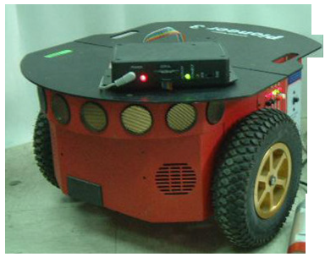
Fig.3.1 Schematic of a wheeled mobile robot

3.3 PATH FOLLOWING PROBLEM

Given a path, initial location p = (x, y) of the mobile robot along with its heading angle (ψ), the path following problem is to determine the commanded heading angle ($ψ_{d}$) for the vehicle such that by following ($ψ_{d}$), the mobile robot accurately tracks the path as the mission progresses. The straight line paths [6] can be defined as a set of waypoints. The angle formed by waypoints W and $W_{i+1}$ is called the line-of-sight (LOS) angle (θ). Assume that the mobile robot is at a distance d from the path. This distance d is called as cross track error. The main objective of path following algorithms is to minimize the cross track error, d and |ψ-θ|🡪 0 as the mission time t 🡪∞.

3.4 STRAIGHT LINE FOLLOWING

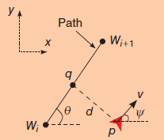
Figure 3.2 Straight line path following

A straight-line path [6] is denoted by two waypoints $W_{i}$ and${ W}_{i+1}$, as shown in figure 3.2 . Following a straight line involves three steps:
1) Determine the cross-track error (d)
2) Update the location of the VTP
Assume the mobile robot is at location p with heading angle ψ. The projection of p onto the LOS is the point q at a distance R from $W_{i}$ . This distance is the cross-track error d. The angle formed by waypoints W and $W_{i+1}$ is called the line-of-sight (LOS) angle (θ).

3.5 ALGORITHM FOR STRAIGHT LINE FOLLOWING

A straight-line path is denoted by two waypoints $W_{i}$ and${ W}_{i+1}$, as shown in below figure 3.3. Following a straight line involves three steps:
1) Determine the cross-track error (d)
2) Update the location of the VTP
Assume the robot is at location p with heading $W_{i}$. The projection of p onto the LOS is the point q at a distance R from${ W}_{i}$ . This distance is the cross-track error d. The VTP (s = ($x_{t},y_{t}$)) is located at a distance d from q. The robot desired heading ϕ is updated based on the location of s. This process continues until the robot reaches
$W_{i+1}$. The procedure to update the location of VTP and $θ_{0}$is given in the below Algorithm . The control input u uses a proportional controller with gain k > 0.

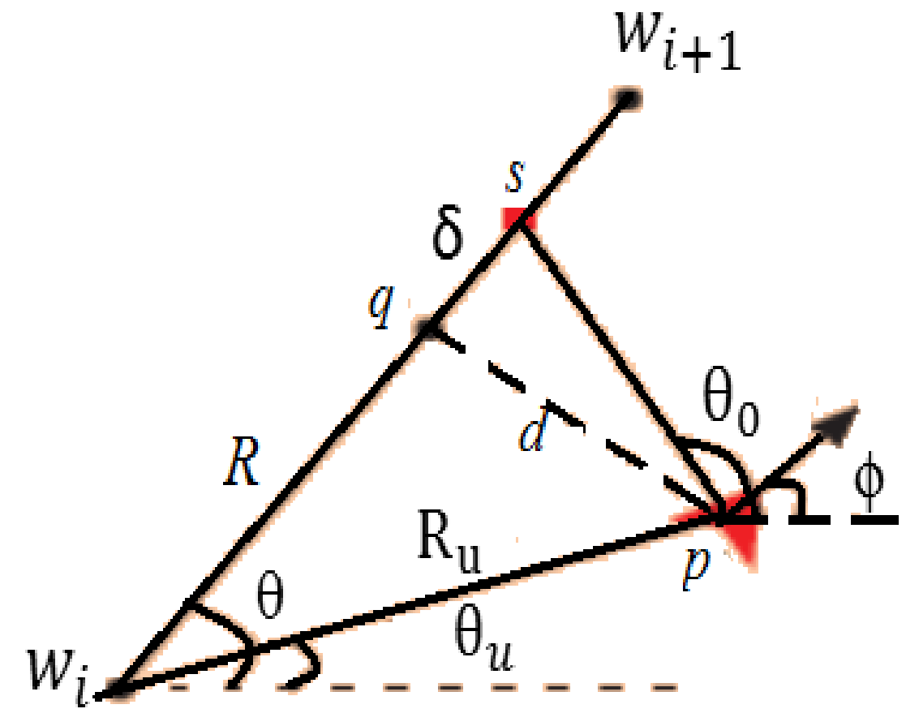
Figure 3.3 Straight line path followed by mobile robot using carrot chasing algorithm

1: Initialize:$W_{i}$=($x_{i,}y_{i}$), p=($x_{c},y_{c}$),$W_{i+1}=(x_{r},y_{r})$
2:${ R}_{u}$= ||$W_{i}$-p||, θ=atan2 ($y_{r}{-y}_{i}{,x}_{r}{-x}_{i}$)
3: $θ_{u}$= atan2 (yc-$y_{i}$, xc-$x_{i}$) ,β=θ-$θ_{u}$
4: R = $\sqrt{{R_{u}}_{}^{2}-{{(R}_{u}sinsin (β ))}_{}^{2}}$
5: ($x_{t}{,y}_{t}$) = ((R+δ)$coscos θ$, (R+δ)$sinsin θ$)
6:theta0=atan2d ((yt-yc), (xt-xc));
7: Xr = xc+dn*cosd (theta0);
8: Yr = yc+dn* sind (theta0);
The path parameter δ can modify the performance of the carrot-chasing algorithm as shown in above figure. For low δ (zero or ten), the mobile robot is forced to move directly towards the LOS. A trajectory to the path that is normal to the path will result in overshoot. A curvature constraint will then result in another trajectory normal to the path, resulting in overshoot again. Hence, it takes more time to settle on the path, resulting in higher cross-track error. With an increase in δ, the robot is able to settle on the path quickly, reducing the cross-track error. However, for even larger values of δ, the cross-track error again increases because the mobile robot is slow in its asymptotic approach to the path.
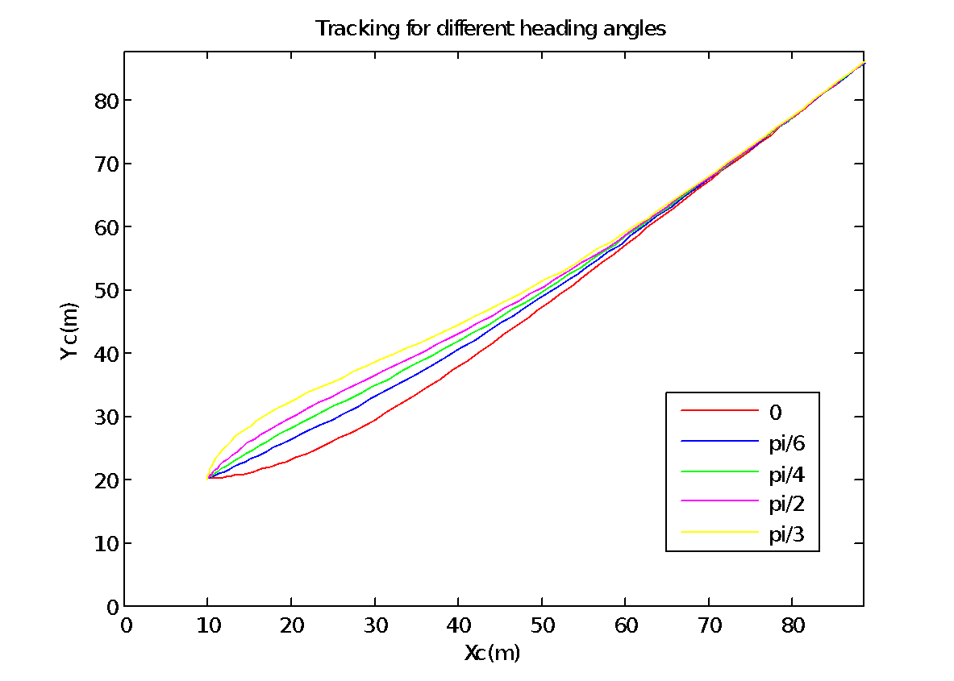
Figure 3.4. Tracking performance for different ϕ

Simulation result for tracking of mobile robot for different heading angle is shown in figure 3.4. For all heading angles, 0, pi/6,pi/3,pi/4,pi/2 mobile robot reaches the straight line i.e. the desired path. The initial point of the mobile robot is taken as (10,20).

3.6 TRACKING CONTROL

The control input u is the torque produced. The error dynamics [1] is responsible for the tracking of robot to the desired path. So we could use the desired path 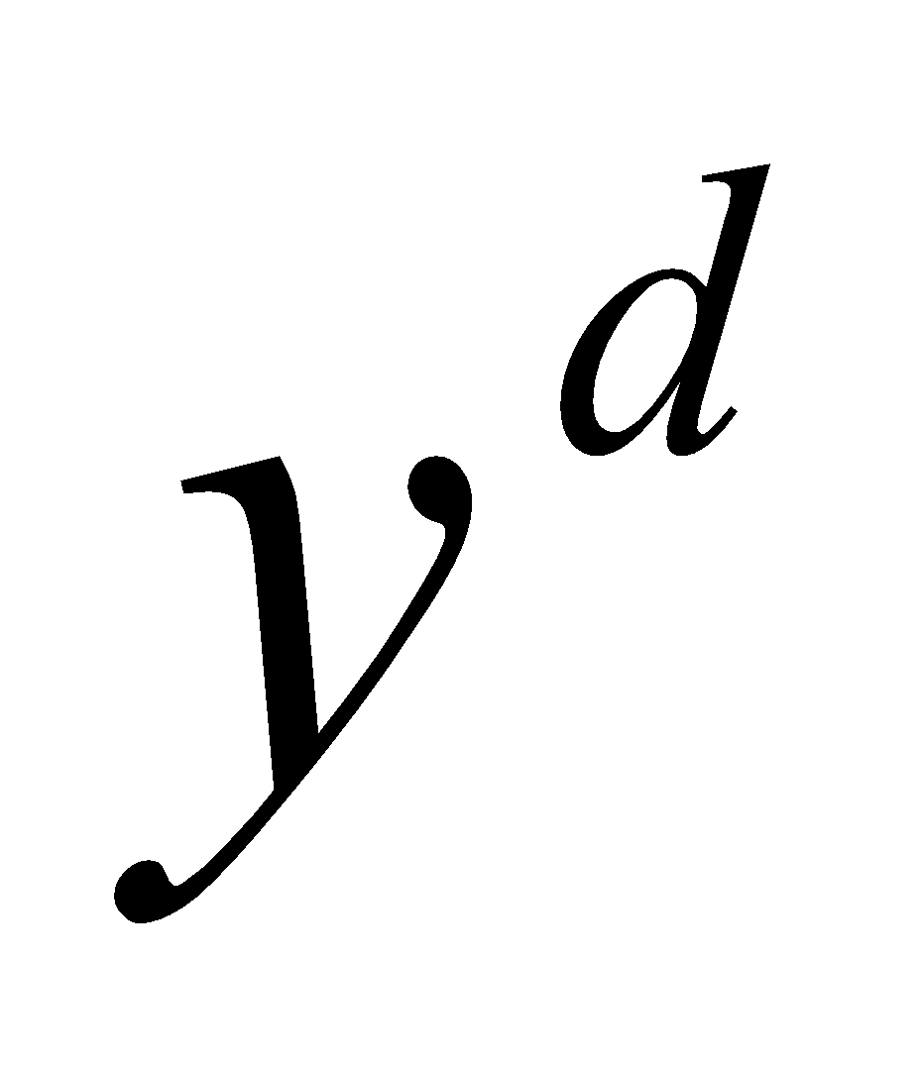 to feed back the error 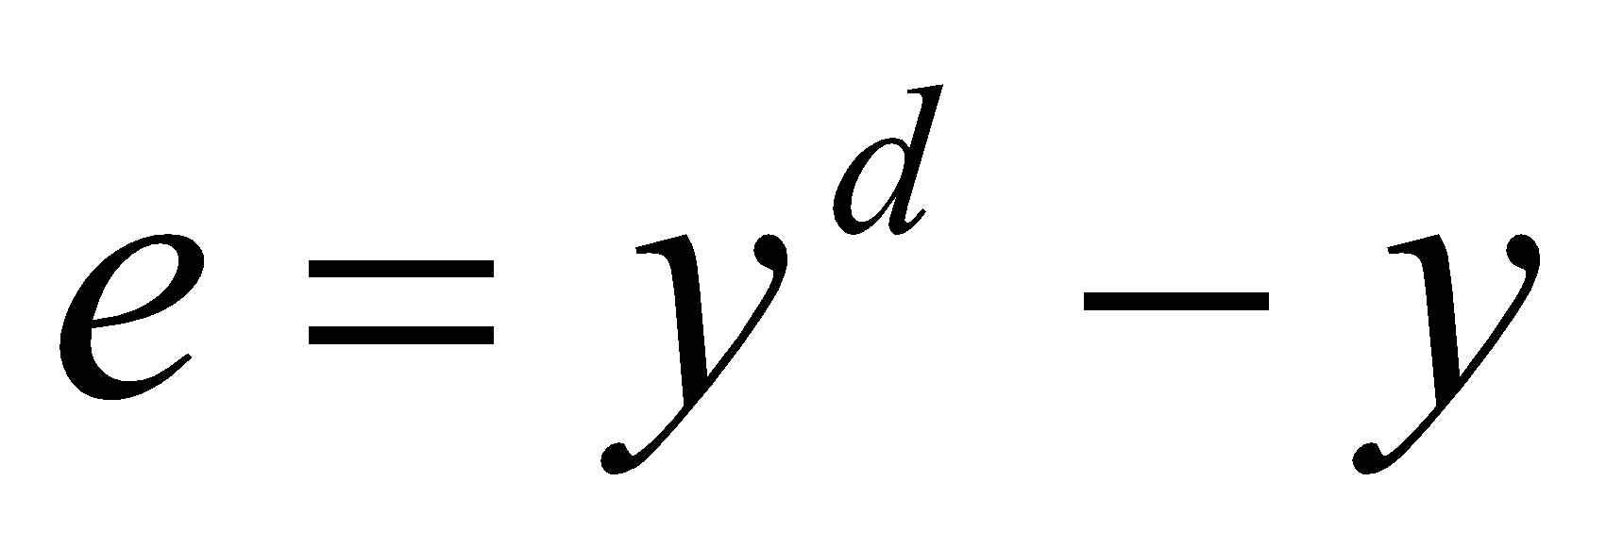
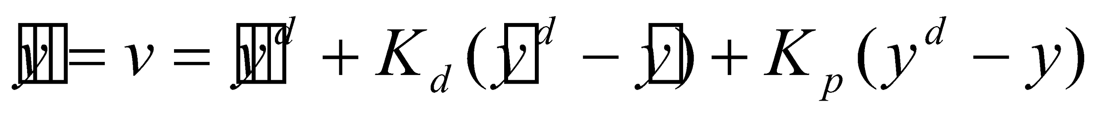 (3.1)
Characteristic equation of the differential equation (3.1) [1] is obtained and gains are selected so that roots are real and negative. When characteristic equation has negative real roots, the error will reduce to zero. kp and kd values are chosen such that the error value is minimum and it gives perfect tracking.
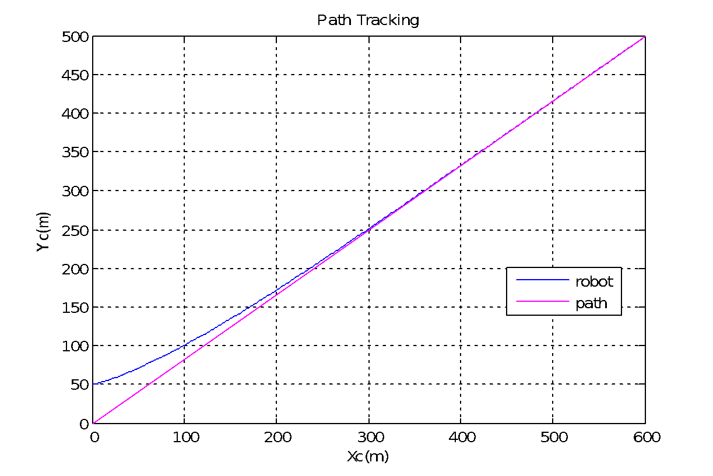
Figure 3.5. Tracking of mobile robot for a straight line
Figure 3.5. shows the tracking performance of mobile robot. The pink line shown in the graph is the desired path where as the blue line is the mobile robot path. The tracking is perfect here. The heading angle of the mobile robot is 45 and the initial point of the mobile robot is taken as (0,50).

3.7 LOITER FOLLOWING

In the loiter [6] maneuver, as shown in figure 3.6, the mobile robot circles around a point (O) with a standoff distance of r. The mobile robot performs the loiter either clockwise or counter clockwise. To loiter, the mobile robot must be located on the circle and its heading direction must be orthogonal to r. Assume the mobile robot is located at p. The cross-track error is d = O -p -r. Using the cross-track error information and the direction of the loiter, the VTP location can be generated. The procedure to update the mobile robot and the VTP is given in algorithms discussed in given chapters.

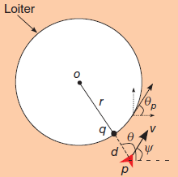
Figure 3.6 Loiter path following

3.8 ALGORITHM FOR LOITER FOLLOWING

For loiter following, CCA [6] is used. This algorithm is explained below.

1: Initialize O=($x_{l }{,y}_{l}$), r, λ
2: θ = atan2(y-$y_{l }$, x-$x_{l}$)
3: ($x_{t}$,$y_{t}$) = (rcos(θ+λ), rsin(θ+λ))
4: $θ_{0}$=atan2 ($y_{t}$-y, $x_{t}$-x)
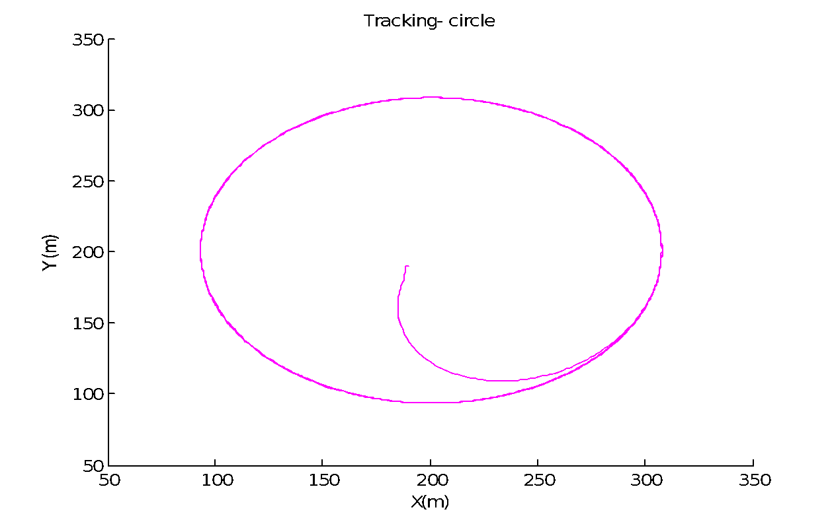
Figure 3.7. Loiter tracking using CCA algorithm

The performance of the carrot-chasing algorithm for loiter following [6] depends on the value for λ. When λ =0, the mobile robot is unable to track the path as the desired VTP always points orthogonal to the robot position causing it to perform a sinusoidal path along the loiter. When λ is increased to λ = 0.1, 0.2, and 0.4 rad, the VTP is in the pursuit range, and hence the vehicle is able to track it quickly. The tracking of loiter by mobile robot is shown in figure 3.7. The centre point of mobile robot is taken as (200,200).

3.9 CONCLUSION

Carrot chasing algorithm [6] adapts the simple method of path following. Introducing a VTP in the path and mobile following the VTP makes the method simpler to implement and it allows the robot to enter its desired predefined path quickly. Also, the tracking control was explained. Simulations were done to show the perfect tracking of the mobile robot to the straight line defined using CCA. In case of any obstacle encountered in the path, the methods to avoid the obstacle are discussed in chapter 4.

CHAPTER 4
OBSTACLE AVOIDANCE

Obstacle avoidance is the main challenge faced in the area of mobile robots which are used for the application of reaching destination in minimum time. There are several algorithms used for avoiding the obstacle. Many of the algorithms are designed using fuzzy logic which proves efficient. Here, in this chapter an obstacle avoidance algorithm [5] and an obstacle avoidance algorithm using fuzzy is designed and explained in detail.

4.1 INTRODUCTION

The obstacle avoidance algorithm is designed based on the orientation of the sensors attached to the mobile robot. These sensors provide the information about the obstacle present, if any, by indicating difference in the distance measured.

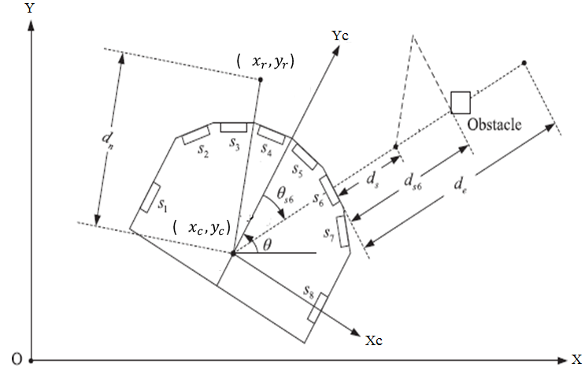
Figure 4.1 Orientation of sensors on the mobile robot
Figure.4.1 shows the orientation of sensors on the mobile robot. A differential wheeled mobile robot is considered. Eight sensors are fixed on the mobile robot at fixed angles. Sensors 1,2,3,4 are considered as left sensors and sensors 5,6,7,8 are considered as right sensors. Based on the distance measured by the sensors, the position of obstacle in the vicinity of the mobile robot is determined. Thus, the robot needs to turn in the opposite direction. The detailed explanation is given in the following sections.

4.2 OBSTACLE AVOIDANCE ALGORITHM
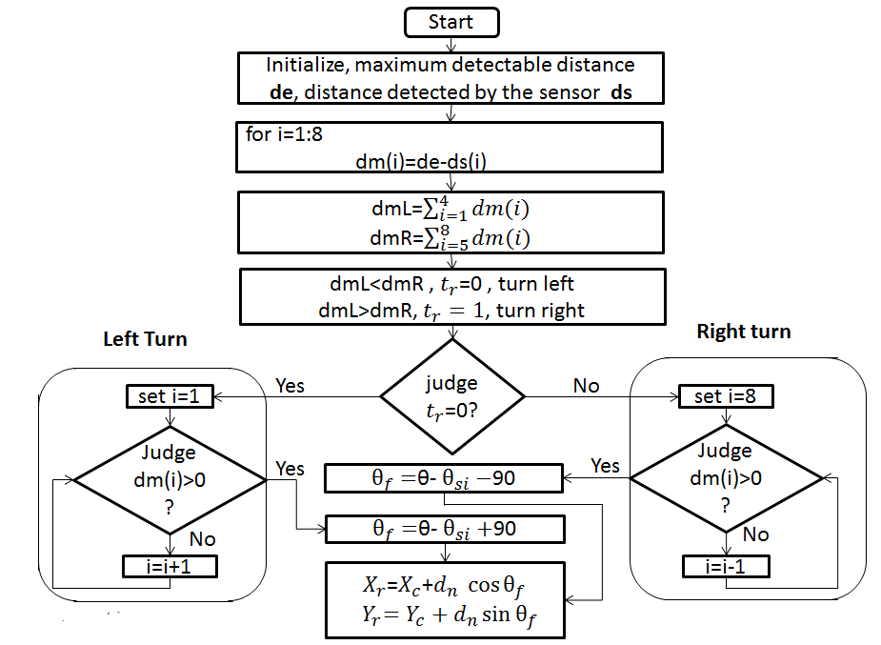

Fig 4.2.Flow chart of obstacle avoidance algorithm.

Figure.4.2. shows the flow chart of obstacle avoidance algorithm. de is the maximum detectable distance, ds is the distance detected by the sensor. When the obstacle around the robot is detected, the right/left command index (tr) can be expressed as:

If $\sum_{i=1}^{4}{}dm(i)$ < $\sum_{i=5}^{8}{}dm(i)$ , then tr =0. (4.1)

If $\sum_{i=1}^{4}{}dm(i)$ > $\sum_{i=5}^{8}{}dm(i)$ , then tr= 1 (4.2)

If condition (4.1) holds, it means that the obstacle is close to the right side of the robot. Thus, one should set the right/left command index as tr = 0 to make the robot turn left to avoid the obstacle. On the other hand, one should set the right/left command index as tr = 1 to make the robot turn right to prevent collision if the condition (4.2) holds. The representation dmL in flowchart is the summation of dm(i), where i = 1,2,3, 4 and dmR is the summation of dm(i), where i=5,6,7,8. This sum of distances decides to where the mobile robot should turn to avoid obstacles. The heading angle $θ_{f}$is given by the equations:
$θ_{f}=θ-θ_{si}-90$, for right turn (4.3)
$θ_{f}=θ-θ_{si}+90$, for left turn (4.4)
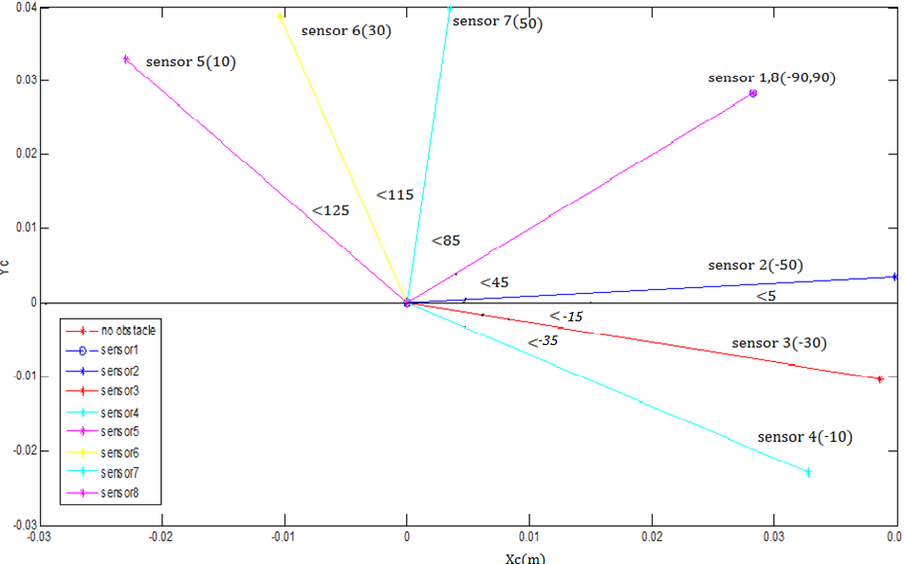

Figure 4.3 Obstacle avoidance using algorithm and the corresponding heading angles
Figure 4.3. shows simulation result for the heading angles of the mobile robot through which it should move for avoiding the obstacle, the initial heading angle being ${45}^{0}$. The initial position of mobile robot is taken as (0,0). As an obstacle is detected at sensor 3, at an angle of ${-30}^{0}$ the robot changes its heading angle and travels through the red line at an angle of ${-15}^{0}$ from the reference axis. This result is obtained using the obstacle avoidance algorithm [5]. The heading angles of the mobile robot are shown in the above simulation result for obstacle at each sensor.

4.3 OBSTACLE AVOIDANCE USING T-S FUZZY INFERENCE SYSTEM

As discussed in the previous sections, the main problem in obstacle detection is the sensor noises that may lead to uncertainties in the system. Fuzzy helps in minimising the noises produced by the sensors while detecting the obstacle. The sensor noises are indicated as difference in distances detected by the sensors which can be considered to frame the rule base. Tagaki- Sugeno inference system is used to frame the rule base.

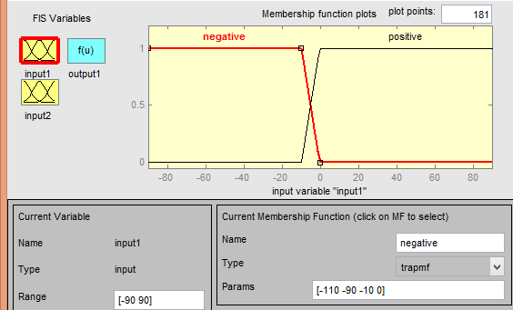
Fig.4.4. Fuzzy input- $θ_{si}$

$θ_{si}$ and d are taken as the two fuzzy inputs of the FIS. Fig.4.4. shows the input $θ_{si}$. Two trapezoidal membership functions, NEGATIVE (N) in the range [-110 -90 -10 0] and POSITIVE (P) in the range [-10 0 90 110] are taken as the input shown in the above figure..
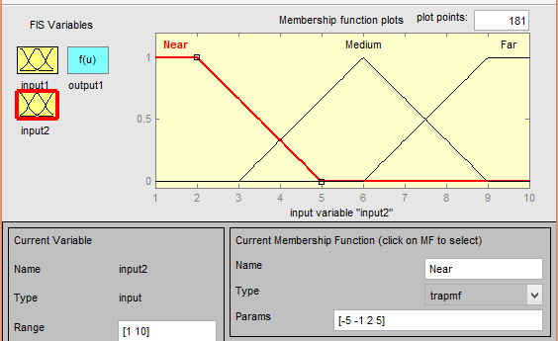
Fig.4.5. Fuzzy input – d
Fig.4.5. shows the second input to the fuzzy. Three membership functions, NEAR (N) which is taken as a trapezoidal membership function in the range [-5 -1 2 5], MEDIUM (M) which is a triangular function in the range [3 6 9] and FAR (F) which is also a trapezoidal membership function in the range [6 9 10 10].

Table 4.1. Fuzzy Rule Base
d  $θ_{si}$ | N | M | F
P | mf1 | mf3 | mf5
N | mf2 | mf4 | mf6
Table 4.1. shows the rule base for the obstacle avoidance using fuzzy. If the fixed angle of the sensor is positive and the distance is near, the output which is activated is mf1 and likewise mf2, mf3 etc. is activated when the respective conditions are satisfied. The output membership functions are described as:
mf1= [-1 0 90]; mf2= [-1 0 -90]; mf3= [-0.8 0 72]; mf4= [-0.8 0 -72]; mf5= [-0.6 0 54]; mf6= [-0.6 0 -54]; where, this 1, 0.8 and 0.6 are the fraction of distance considered for near, medium and far respectively.
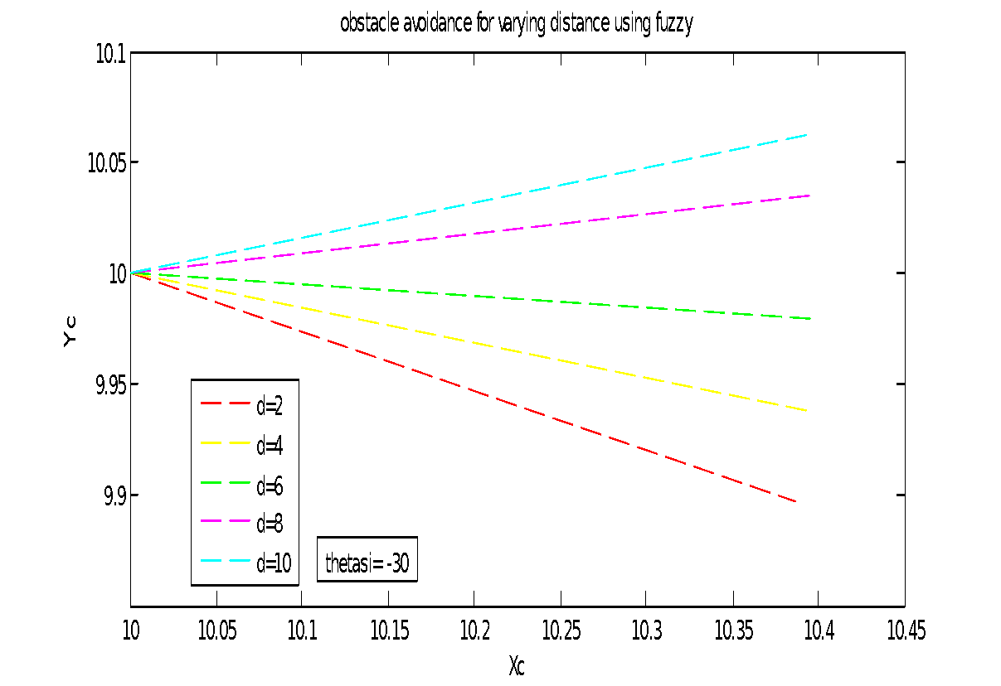
Fig.4.6. Deviation of robot with variation in presence of the obstacle.

Fig.4.6. is the simulation result for the variation in distance where the obstacles are present. The logic used in this is that if the obstacle is present at a distance near to the mobile robot then the deviation taken by the robot is maximum i.e. the red line shown in the above graph. If the obstacle is at a medium distance then the deviation taken is medium, green line in the graph. If the obstacle is present at a far distance from the robot then the robot needs to take only a small deviation in order to avoid the obstacle, blue line in the graph..
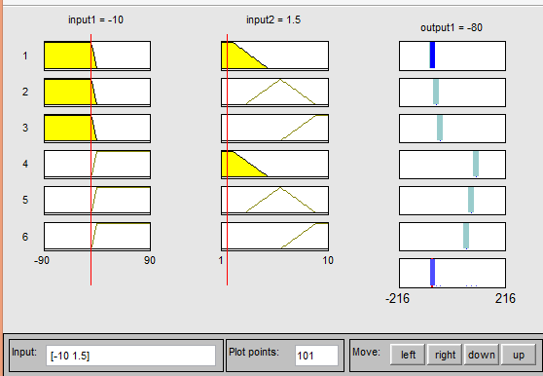
Fig.4.7. Output calculation for two particular inputs

Figure.4.7. shows the output for two particular inputs. For $θ_{si}$=-10 and for distance d=1.5, the output ie. the turning angle is obtained as -80. On summation with the heading angle we will obtain the desired heading angle i.e. -80+45= -35. So after avoiding the obstacle which is at 1.5 distance from sensor 1 (-10), the robot will head in the direction of -35 from the reference axis.
Figure 4.8. shows simulation result for the heading angles of the mobile robot through which it should move after avoiding the obstacle. The heading angles of the mobile robot are shown for obstacles at each sensor, the initial heading angle being ${45}^{0}$. The initial position of mobile robot is taken as (10,10). As an obstacle is detected at sensor 5, at an angle of ${10}^{0}$ the robot changes its heading angle and travels through the blue line at an angle of ${125}^{0}$ from the reference axis. This result is obtained using the obstacle avoidance with fuzzy design.
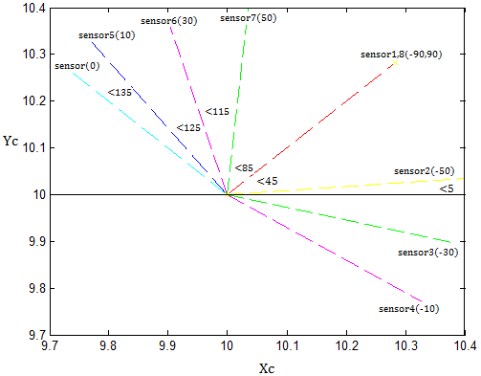
Fig.4.8.Obstacle avoidance using fuzzy design.

4.4 CONCLUSION

An obstacle avoidance algorithm was discussed in this chapter. It avoided the obstacle but was not adaptable to sensor noises. Thus, to make the system adaptive to sensor noise, a T-S based fuzzy logic controller was designed which helped in reducing the sensor noises by taking the variation of distance into account. In chapter 5, locomotion of mobile robots using obstacle avoidance algorithm [5] and obstacle avoidance using fuzzy are explained in detail and their results are compared.

CHAPTER 5
LOCOMOTION OF MOBILE ROBOT

Nowadays, mobile robots are a promising technology that will improve the quality of life by providing collision avoidance, reducing traffic gridlock, and allowing the replacement of dangerous tasks currently performed by human drivers. The path-planning for the objective of obstacle avoidance, which is one of the key issues in the mobile robot navigation. The tracking algorithm is combined with the obstacle avoidance algorithm and obstacle avoidance with fuzzy logic and their performances are analysed

5.1 INTRODUCTION

In the previous chapters and sections, tracking algorithms and obstacle avoidance algorithms were discussed separately. Comparison of algorithms is done to analyse their performance. A switching path planning control scheme is proposed which switches between the path tracking and obstacle avoidance control [5], helps the robot in efficiently reaching the target avoiding the obstacles in the unknown environments with less memory size. For tracking, the Carrot Chasing Algorithm [6] is used. In obstacle avoidance, an algorithm is designed using the sensors and obstacle position. Intelligent adaptive schemes are used to avoid the uncertainties from external environment and sensor noises which give way to more adaptive and easier approach. The combination and their comparison is explained in detail in the following sections.

5.2 LOCOMOTION USING OBSTACLE AVOIDANCE ALGORITHM

Combination of tracking algorithm with obstacle avoidance algorithm [5] can be seen in the given simulation result.
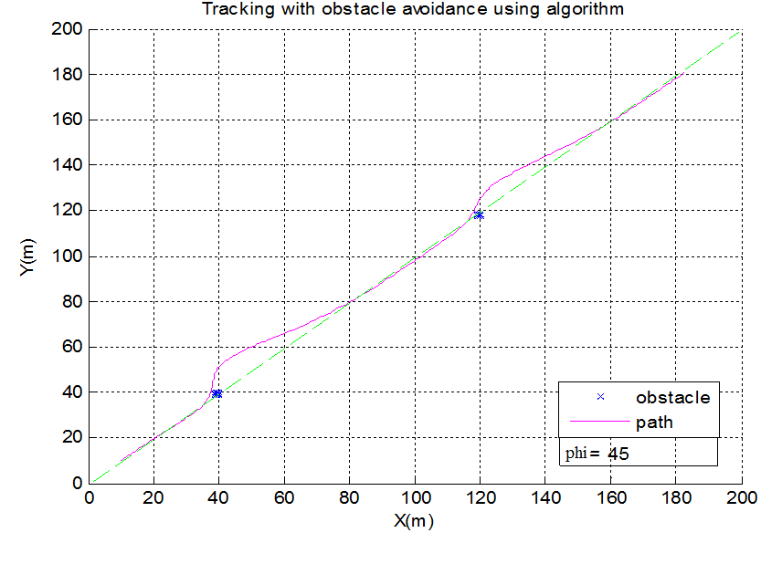
Fig.5.1. Tracking with obstacle avoidance algorithm.

Figure.5.1. shows the simulation result for tracking with obstacle avoidance using CCA [6] and obstacle avoidance algorithm [5]. In the result, the green line shows the desired path, blue dots indicates the obstacles and the pink line shows the tracking with obstacle avoidance. The initial point of robot is taken as (10,10) with a heading angle of ${45}^{o}$. First, the robot is tracking the desired path and as it detects the obstacle robot deviates from the obstacle and it again get backs to the desired path. When the robot is tracking the desired path the control is switched to tracking control and when the obstacle detects the obstacle it is switched to obstacle avoidance control. Switching between the algorithms takes place throughout, till it reaches the destination point. This process repeats till it reaches the destination point.

5.3 LOCOMOTION USING FUZZY LOGIC

In this section, the combination of tracking with obstacle avoidance using fuzzy logic is explained. The simulation results for the tracking with obstacle avoidance using fuzzy is obtained and is shown below.
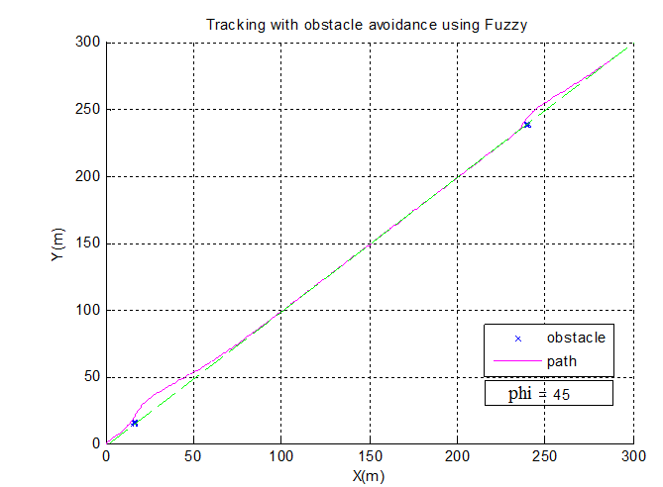
Fig.5.2. Tracking with obstacle avoidance using fuzzy logic

Figure 5.2 shows the simulation result for tracking with obstacle avoidance using fuzzy logic. In the result, the green line shows the desired path, blue dots indicates the obstacles and the pink line shows the tracking with obstacle avoidance. First, the robot is tracking the desired path and as it detects the obstacle robot deviates from the obstacle and it again get backs to the desired path. The initial starting point of robot is taken as (0,0) with an initial heading angle of ${45}^{o}$. When the robot is tracking the desired path the control is switched to tracking control and when the obstacle detects the obstacle it is switched to obstacle avoidance control. Switching between the algorithms takes place throughout, till it reaches the destination point. This process repeats till it reaches the destination point.

5.4 COMPARISON OF LOCOMOTION USING OBSTACLE AVOIDANCE ALGORITHM AND FUZZY.
In this section, the comparison between the tracking with obstacle avoidance algorithm [5] and tracking with obstacle avoidance algorithm using fuzzy is done and simulation results are shown below.
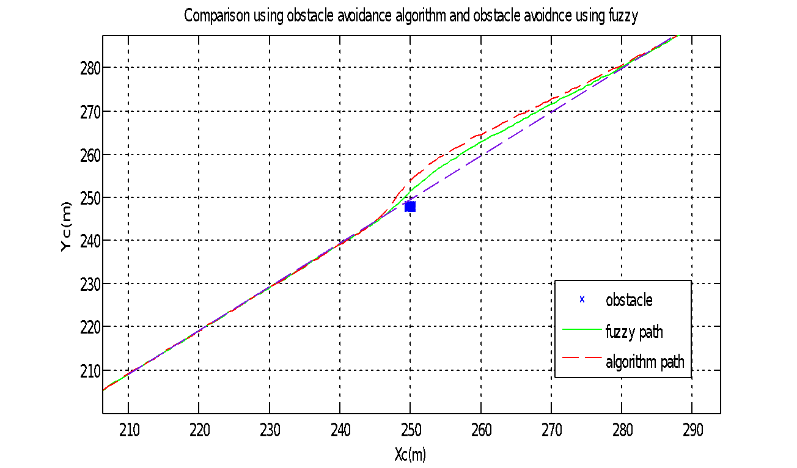
Fig.5.3. Comparison between tracking with obstacle avoidance algorithm and algorithm using fuzzy

Figure.5.3. shows the simulation result obtained for the comparison of the two algorithms. From the simulation result, it is clearly visible that the fuzzy designed algorithm has less deviation compared to the other algorithm. In the above figure, blue line indicates the desired path, red line shows the algorithm path and the green line shows the fuzzy path. The initial heading angle of robot for both case is taken as ${45}^{0}$. The deviation of fuzzy path is much less compared to the algorithm path and the memory size is less since the obstacle or the path is not saved. The time taken by the fuzzy path to reach back to the desired path is less compared to the algorithm path.

5.5 CONCLUSION

Comparison between the path tracking with obstacle avoidance using algorithm and tracking with obstacle avoidance using fuzzy logic was done. From the simulation results, it was seen that the deviation of fuzzy path is much less compared to the algorithm path and the memory size is less since the obstacle or the path is not saved. The time taken by the fuzzy path to reach back to the desired path is less compared to the algorithm path.

CHAPTER 6
HARDWARE

In this chapter, the hardware implementation of the simulations shown in the above chapters is explained. The block diagram, components required, robot model, microcontroller used for the framework of hardware are explained in this chapter.

6.1 INTRODUCTION

A two wheeled mobile robot is designed and assembled for the implementation and testing of intelligent adaptive path tracking algorithm with obstacle avoidance in which the path is defined using the Carrot Chasing Algorithm and obstacle avoidance is done using the fuzzy logic controller. Major components used are dc motors, wheels, encoding sensors, sharp IR sensors for obstacle detection, regulators, supply batteries and the motor driver circuit. Detailed explanation of each component is given in the following sections. The basic block diagram for the hardware implementation is explained below.

6.2 BLOCK DIAGRAM

The block diagram for the hardware setup is explained in this section. The figure shown below gives an idea about the hardware framework. The main power supply used is 9V Battery. This 9V supply is given to the regulator which gives regulated 5V. The output of regulator is given as the supply for sensors and microcontroller. The output of microcontroller is given as the inputs for the motor driver IC. The motor driver IC drives the two dc motors which are connected to the wheels used to move the robot. The speed of the motor is obtained from the encoder and fed back to the microcontroller to get the position of the robot.
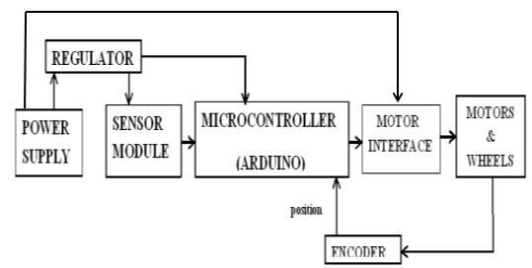
Fig.6.1 Block diagram of hardware

6.3 COMPONENTS

6.3.1 POWER SUPPLY

Power supply used to drive the robot is 9V. A constant 9V DC supply or a 9V DC battery of required ampere ratings can be used.

6.3.2 REGULATOR IC 7805

IC 7805 is a voltage regulator integrated circuit. It is a member of 78xx series of fixed linear voltage regulator ICs. The voltage source in a circuit may have fluctuations and would not give the fixed voltage output. The voltage regulator IC maintains the output voltage at a constant value. The xx in 78xx indicates the fixed output voltage it is designed to provide. 7805 provides +5V regulated power supply. Capacitors of 10microF is used in the output and 100microF is used at the input. The pinout diagram for L7805 IC is shown below. The input range is 5V-18V and it gives a regulated output voltage in the range 4.8V-5.2V.

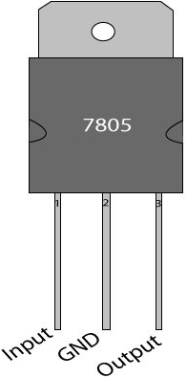
Fig.6.2 Pinout of L7805

6.3.3 SPEED ENCODER

Encoding is used to get the velocity of the robot from the wheel rotation. The velocity is calculated by using distance travelled by the wheel and time taken for it. For obtaining 18 pulses for a complete rotation, 18 alternate black and white strips are drawn on wheel.

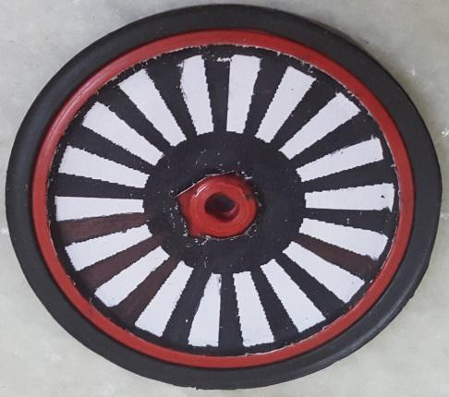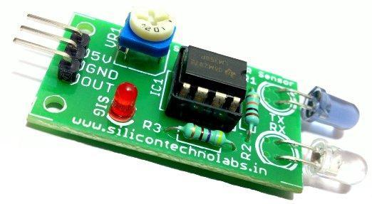Fig.6.3 Wheel with encoding strips Fig.6.4 IR sensor
The black strip absorbs the IR rays emitted by IR transmitter in the sensor whereas the white strip reflects the IR rays. The reflected IR rays are sensed by the IR receiver in the sensor. Hence pulses are obtained when the sensor traverse the alternate white and black strips
The calculation of velocity is shown below. Number of pulses considered for the calculation is 18 pulses.
18 pulses=1 revolution=2*π*r=2*3.14*3.4cm=21.352 ~ 21cm. (6.1)
1 pulse = 21/18 = 1.16cm = 0.0116m. (6.2)
If time for 1 pulse = 1ms = 0.001s (6.3)
d= 0.0116m, t= 0.001s (6.4)
V= d/t = 0.0116/0.001 = 11.6m/s. (6.5)

6.3.4 IR RANGE SENSOR

For measuring the distance to an object there are optical sensors using triangulation measuring method. Infra-red (IR) wavelength using distance sensors which have analogue voltage output is given by this IR range sensors. The sensors have IR LED equipped with lens, which emits narrow light beam. After reflecting from the object, the beam will be directed through the second lens on a position-sensible photo detector (PSD). The conductivity of this PSD depends on the position where the beam falls. The conductivity is converted to voltage and if the voltage is digitalized by using analogue-digital converter, the distance can be calculated. The output of distance sensors is inversely proportional, this means that when the distance is growing the output is decreasing (decreasing is gradually slowing). All sensors have their specific measuring range where the measured results are creditable and this range depends on the type of the sensor. Fig.6.5 shows an IR range sensor.
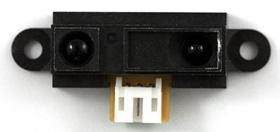
Fig .6.5 IR range sensor
Maximum distance measured is restricted by two aspects: the amount of reflected light is decreasing and inability of the PSD registering the small changes of the location of the reflected ray. When measuring objects which are too far, the output remains approximately the same as it is when measuring the objects at the maximum distance. Minimum distance is restricted due to peculiarity of Sharp sensors, meaning the output starts to decrease (again) sharply as the distance is at certain point (depending on the model 4-20 cm). This means that to one value of the output corresponds two values of distance. This problem can be avoided by noticing that the object is not too close to the sensor. The working principle of IR range sensor is shown in the below figure 6.6.

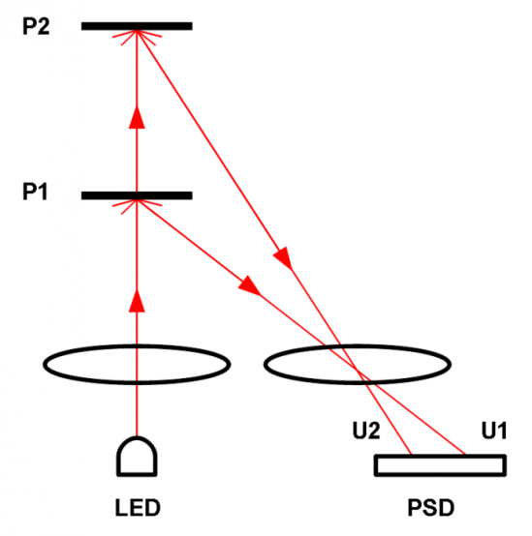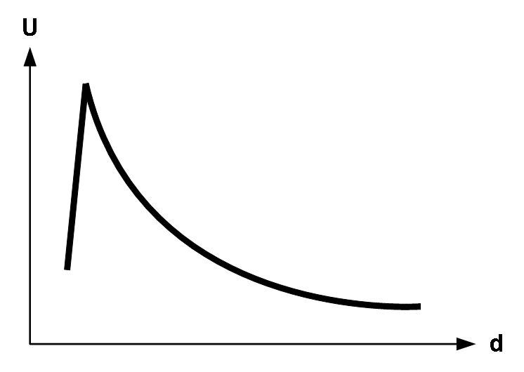
Fig.6.6 Working principle of IR Fig.6.7. Characteristic plot of IR

Fig.6.7 shown above indicates the variation of analog voltage with respect to distance. It shows an inverse relationship. The distance is inversely proportional to voltage. Minimum distance of IR sensor is taken to be 10cm where as maximum distance is considered to be 80cm. Distance is measure using ADC conversion of IR sensor.

6.3.4.1 CALIBRATION OF IR RANGE SENSOR

As the principle states, voltage decreases as the distance increases. In order to calibrate, voltage corresponding to the distances is calculated using ADC conversion. Graph is plotted with distance as x axis and voltage as y axis.

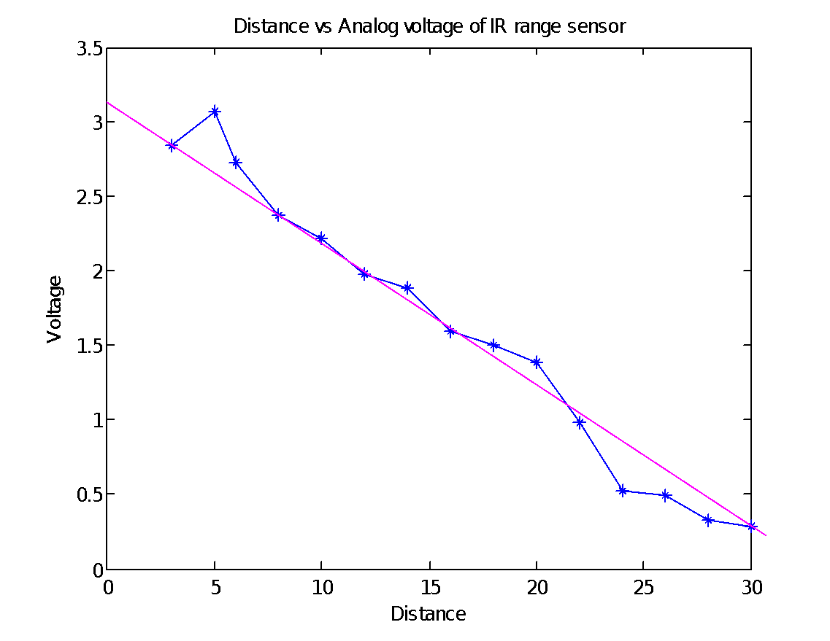
Fig 6.8 Calibration curve for voltage vs distance plot
From the fig.6.8, calibrated equation for distance can be formed by finding the slope and y intercept. For linear approximation, outer points are neglected. The equation for distance is obtained as,
D=(V-3.16)/-0.1 (6.6)

6.3.5 MICROCONTROLLER – ARDUINO

The microcontroller used for controlling the mobile robot is ARDUINO- UNO microcontroller.

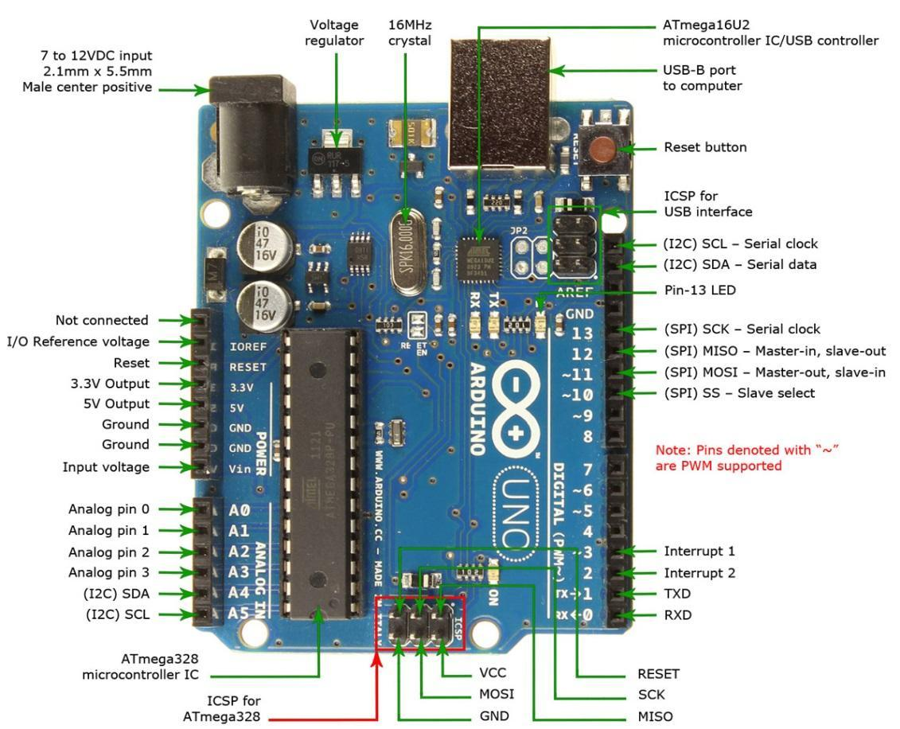
Fig.6.9 Pin diagram of arduino uno

The Uno is a microcontroller board based on the ATmega328P. It has 14 digital input/output pins (of which 6 can be used as PWM outputs), 6 analog inputs, a 16 MHz quartz crystal, a USB connection, a power jack, an ICSP header and a reset button. It contains everything needed to support the microcontroller; connect it to a computer with a USB cable or power it with a AC-to-DC adapter or battery to get started.

6.3.6 L293D MOTOR DRIVER IC

L293D is a dual H-bridge motor driver integrated circuit (IC). Motor drivers act as current amplifiers since they take a low-current control signal and provide a higher-current signal. This higher current signal is used to drive the motors. L293D contains two inbuilt H-bridge driver circuits. In its common mode of operation, two DC motors can be driven simultaneously, both in forward and reverse direction. The motor operations of two motors can be controlled by input logic at pins 2 & 7 and 10 & 15. Input logic 00 or 11 will stop the corresponding motor. Logic 01 and 10 will rotate it in clockwise and anticlockwise directions, respectively. Enable pins 1 and 9 (corresponding to the two motors) must be high for motors to start operating. When an enable input is high, the associated driver gets enabled. As a result, the outputs become active and work in phase with their inputs. Similarly, when the enable input is low, that driver is disabled, and their outputs are off and in the high-impedance state. Fig.6.10 shows the pin diagram of L293D IC.
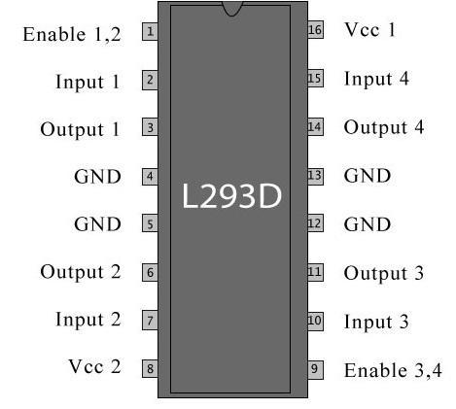
Fig.6.10 Pin diagram of L293D IC
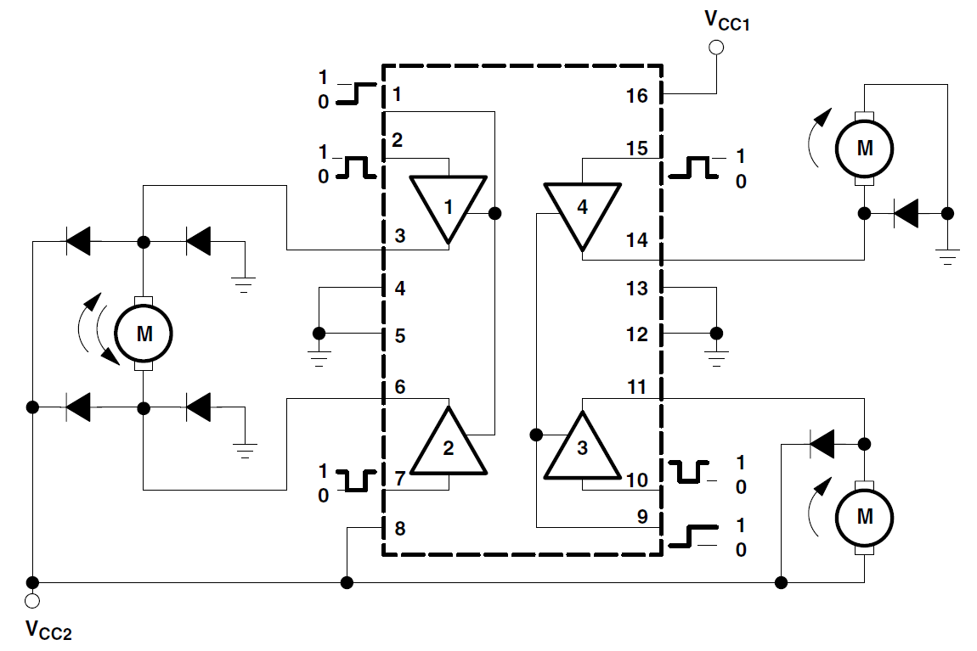
Fig.6.11 Working diagram of L293D

Fig.6.11 shows the working diagram of l293d IC with motors connected to it. There are 4 input pins for l293d, pin 2,7 on the left and pin 15 ,10 on the right as shown on the pin diagram. Left input pins will regulate the rotation of motor connected across left side and right input for motor on the right hand side. The motors are rotated on the basis of the inputs provided across the input pins as LOGIC 0 or LOGIC 1.In simple you need to provide Logic 0 or 1 across the input pins for rotating the motor. Consider a Motor connected on left side output pins (pin 3,6). For rotating the motor in clockwise direction the input pins has to be provided with Logic 1 and Logic 0.
• Pin 2 = Logic 1 and Pin 7 = Logic 0 | Clockwise Direction
• Pin 2 = Logic 0 and Pin 7 = Logic 1 | Anticlockwise Direction
• Pin 2 = Logic 0 and Pin 7 = Logic 0 | Idle [No rotation] [Hi-Impedance state]
• Pin 2 = Logic 1 and Pin 7 = Logic 1 | Idle [No rotation]
The motor can also operate across input pin 15, 10 for motor on the right hand.

6.3.7 DC MOTOR

For the implementation of this project, a 9V 60rpm constant speed DC motor is selected. Two 60rpm DC motors are used to drive the robot. It gives 60 revolutions per minute. Fig 6.12 shows the DC motor used in this project.

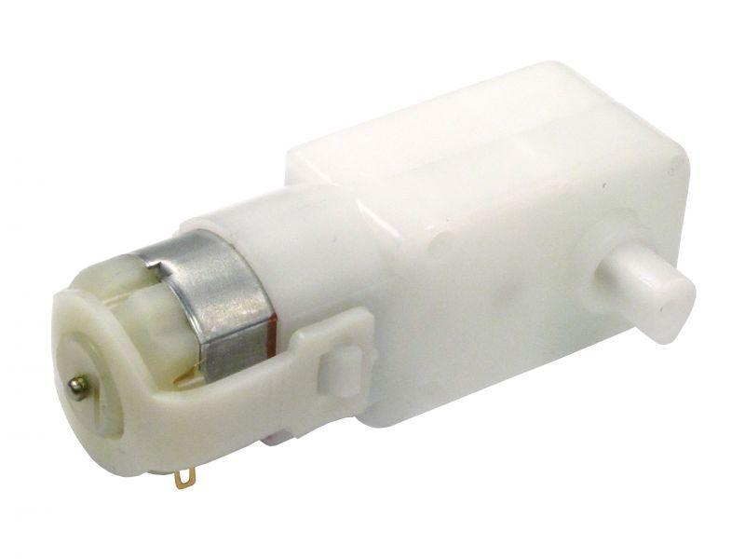
Fig.6.12 DC motor
A geared DC Motor has a gear assembly attached to the motor. The speed of motor is counted in terms of rotations of the shaft per minute and is termed as RPM .The gear assembly helps in increasing the torque and reducing the speed. Using the correct combination of gears in a gear motor, its speed can be reduced to any desirable figure. This concept where gears reduce the speed of the vehicle but increase its torque is known as gear reduction.
Specifications:

Voltage(v) | 3-9v
Current | 0.01a(no load);0.07a(at max. eff.)
Locked-rotor current | >=0.15a
Speed(rpm) | 60rpm+-10%(no load)
Torque | 0.5kg-cm
Rotation | cw/ccw
6.3.8 WHEELS
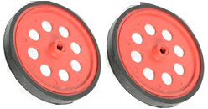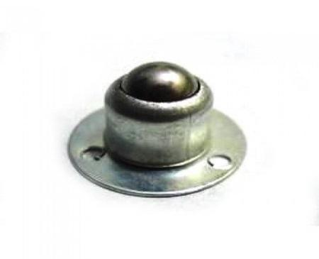
Fig 6.13 Wheels Fig 6.14 Castor Wheel

Fig.6.13 shows the wheels used in the model to run the robot. These wheels are locked to the motor shaft which is 6.8cm in diameter. Fig. 6.14 shows the castor wheel which is a passive self- adjusting wheel which balances the robot while in motion.

6.4 HARDWARE DESCRIPTION

Intelligent adaptive path tracking and collision avoidance of mobile robot is implemented on a differential drive robot which is balanced with the help of a passive self-adjusting castor wheel. The power supply of 9V is given to the regulator IC (LM7805) whose output voltage is a regulated 5V which provides the supply for the IR range sensors and the enable pins of the motor driver IC (L293D). The microcontroller is given an input voltage of 9V. Three analog inputs from the IR range sensors, two digital inputs from the speed encoding IR sensors are fed to the microcontroller as the inputs. These data are processed and the output is given to the PWM pins of the motor according to which the motor moves forward, turn left or turn right or stop. The motor is attached to wheels. The robot is balanced by a castor wheel which adjusts itself to comfort the robot motion.
The value given to the PWM pins depends on the duty ratio and the corresponding analog value. Left and Right turns are achieved by reducing the PWM value in the corresponding wheel to which side the robot has to turn. For left turn, PWM value is reduced in the PWM pin corresponding to left wheel and for right turn PWM value is reduced in the pin corresponding in the right wheel. Equal value is given in both pins for the robot to move straight. The values of PWM corresponding to duty cycle is shown below.
0 – 5V - 0 – 255
100% duty cycle – 255
75% duty cycle – 191
50% duty cycle – 127
Fig.6.15 shows the front view and top view of the mobile robot model.

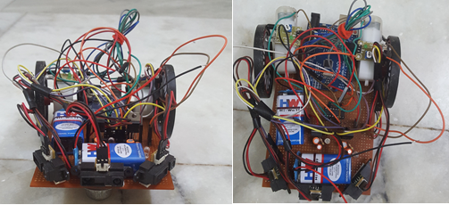

Fig.6.15. Front view and top view of hardware model

6.5 CONCLUSION
In this chapter, the hardware setup of mobile robot is explained. All the components used in the hardware are explained in this section. In the next chapter, the results obtained with the hardware is explained and analysed.

CHAPTER 7
HARDWARE RESULTS

Results obtained using the hardware is explained in this chapter tracking, obstacle avoidance and the combined tracking with obstacle avoidance is explained.

7.1 TRACKING

Tracking is done using Carrot Chasing Algorithm (CCA).CCA is used to define the straight line path which the robot has to track. The output values of tracking is given below. Here, the initial position is given as U=60, V=10 and the desired heading angle as 45. According to the position of mobile robot it has to move left to get into track ie, when the actual heading angle becomes equal to the desired heading angle the robot gets into track.

TRACKING

timeold= 166
tfinal= 323.00

pulses = 2
ds = 1.16
t = 157.00
Vl = 7.39

timeold= 328
tfinal= 433.00

pulses = 2
ds = 1.16
t = 105.00
Vr = 11.05

looptimestart= 439.00

DT= 0.06
T= 0.85

DU= 3.85
U= 63.85

DV= 4.37
V= 14.37

thetau= 0.22
beta= 0.56
x_desire = 53.25
y_desire = 53.25

phiD = 1.84
TA= 0.99

Vl= 8.96
DVl= 127.00

Turn left

looptime end= 671.00
7.2 OBSTACLE AVOIDANCE

Obstacle avoidance in this hardware is done using fuzzy logic controller. Three IR sensors are kept at fixed angles of -45, 0, 45 to detect obstacle. The inputs taken for fuzzy algorithm are fixed sensor angle and distance given by the IR sensors.
The nearest obstacle is considered. The turning angle is calculated so that the obstacles are avoided. The minimum distance calculated from the analog voltage given by the sensor indicates the presence of nearest obstacle. The output values of obstacle avoidance is shown below.

OBSTACLE AVOIDANCE

V0= 1.05
D0= 19.89
Dm0= 0.00

V1= 1.34
D1= 18.30
Dm1= 0.00

V2= 1.49
D2= 24.70
Dm2= 0.00

Tsi 0.00
d 18.30

Tnegative 0.00
Tpositive 1.00
Dnear 0.34
Dmedium 0.66
Dfar 0.00
Z = -1.57

Vl= 1.85
DVl= 127.00

Turn left

7.3. COMBINED TRACKING AND OBSTACLE AVOIDANCE

Tracking and obstacle avoidance is combined in this section. The output of combined tracking with obstacle avoidance is shown below. The switching of algorithms are done here. The tracking algorithm gets activated when there is no obstacle on the way and it switches to obstacle avoidance algorithm when an obstacle is detected on its path.

COMBINED TRACKING AND OBSTACLE AVOIDANCE

timeold= 1483
tfinal= 1549.00

pulses = 2
ds = 1.16
t = 66.00
Vl = 17.58

timeold= 1558
tfinal= 1665.00

pulses = 2
ds = 1.16
t = 107.00
Vr = 10.84

looptimestart= 1672.00
DT= -0.09
T= 0.92

DU= 4.30
U= 28.78

DV= 5.67
V= 32.87

TRACKING

thetau= 0.85
beta= -0.07
x_desire = 44.97
y_desire = 44.97

phiD = 0.64
TrnAng= -0.28

Vr= 17.58
DVr= 213.00

Turn right

looptime end= 1927.00

timeold= 2728
tfinal= 2781.00

pulses = 2
ds = 1.16
t = 53.00
Vr = 21.89

looptimestart= 2804.00

DT= -0.02
T= 0.91

DU= 6.17
U= 34.95

DV= 7.88
V= 40.75

Tsen 0.00
ds 13.18

Tnegative 0.00
Tpositive 1.00
Dnear 1.00
Dmedium 0.00
Dfar 0.00
Z = 1.57

Vl= 1.85
DVl= 127.00
Turn left
OBSTACLE AVOIDANCE

Tsen 0.00
ds 13.18

Tnegative 0.00
Tpositive 1.00
Dnear 1.00
Dmedium 0.00
Dfar 0.00
Z = 1.57

Vl= 1.85
DVl= 127.00

Turn left
looptime end= 3244.00

7.4 CONCLUSION

In this chapter hardware results obtained while tracking, obstacle avoidance using fuzzy and the combined tracking with obstacle avoidance is explained. The results were observed. The switching between tracking and obstacle avoidance is done.

CHAPTER 8
CONCLUSIONS AND FUTURE SCOPE

In this project, path tracking with obstacle avoidance algorithm and path tracking with obstacle avoidance algorithm using fuzzy are discussed and their performances are analysed. The basic differential mobile robot model was considered for the simulation. The main aim of the project was to design an algorithm for tracking with obstacle avoidance which is less complex, have less memory size, and takes minimum time to reach destination. Switching of algorithms used in the project helps to reduce the complexity in computation. The fuzzy design used here helps to reduce the uncertainties caused by the sensors. Efficient tracking with obstacle avoidance is achieved by using the design discussed in this project.
In tracking, CCA algorithm is used to define the path and the error dynamics are used to achieve tracking. In CCA, a VTP is introduced in the path and the robot follows the VTP to track the desired path. Adjusting K_{p} and K_{d} values, perfectly tracks the robot onto the desired path. Also, loiter tracking was explained using the CCA algorithm.
In obstacle avoidance algorithm, the steps to avoid obstacles are designed by the orientation of the sensors attached to the mobile robot. These sensors provide the information about the obstacle present, if any, by indicating difference in the distance measured. Minimum distance was taken into consideration. This method efficiently avoided the obstacles but was not adaptable to uncertainties caused by the sensors.
To avoid the uncertainties caused by the sensors, a fuzzy based obstacle avoidance algorithm was designed. T-S fuzzy inference system was used to frame the rule base. This design indicated the sensor noises as difference in distances detected by the sensors. Thus, it reduced the effect of sensor noises.
Combining the tracking and obstacle avoidance algorithms, both worked together efficiently. Tracking and obstacle avoidance using algorithm, showed a greater deviation compared to the obstacle avoidance algorithm using fuzzy. Also, the time taken by the algorithm to get back to the desired path was little greater compared to the time taken by the fuzzy designed algorithm.
Comparison between the path tracking and obstacle avoidance using algorithm and obstacle avoidance using fuzzy logic was done. From the simulation results, it was seen that the deviation of fuzzy path is much less compared to the algorithm path and the memory size is less since the obstacle or the path is not saved. The time taken by the fuzzy path to reach back to the desired path is less compared to the algorithm path. Thus, an efficient algorithm is designed using T- S fuzzy for avoiding the obstacle with less deviation. The combined tracking with obstacle avoidance using fuzzy showed a good result with less deviation, less memory size, less complexity which was achieved due to the switching between the algorithms.
Hardware implementation is done with a differential drive wheeled robot. IR sensors are used for obstacle detection. Tracking is done using CCA and obstacle avoidance is done using fuzzy. Switching between tracking and obstacle avoidance using fuzzy logic is implemented and the results were observed.
Future scope of this project is that the design can be modified to avoid moving obstacles.

